**Dhow and Camping Trip to Daymaniyat Islands in Oman from 8/9 to 10 November, 2018**

The DNHG is organizing a weekend trip to Oman, with the dhow trip to the natural reserve of Daymaniyat Islands for an overnight camping and two days of snorkeling and exploring this archipelago with rich marine and bird life.

We have managed to secure the dhow and all necessary permits for the weekend 9/10 November for an exclusive camping trip on Daymaniyat islands, a natural reserve with restricted access: the islands are closed to visitors in summer months to allow for undisturbed breeding of birds and marine life.

**Trip details:**

**Thursday, 8 November:**

You will leave Dubai at your convenience (we will not drive in convoy) to reach the meeting location in Oman by Thursday evening, possibly before 5 pm (to set the camp before dark). Alternatively, you can stay in a hotel of your choice or join later in the evening/morning, as long as you are at the meeting point for the boat pick up latest at 8 am on Friday morning.

Exact location will be communicated additionally. Please consider 5 hrs drive (+ border time) from Dubai to the meeting point.

You will need to get the Omani visa, either at the border or preferably on line (<https://evisa.rop.gov.om/>).

You will obviously need your passport, valid Omani car insurance with orange card and all necessary documents in case you drive rented or leased car.

Costs: exit UAE 35 AED, visa for Oman 5 OMR/50 AED.

**4WD car will not be needed.**

**Friday, 9 November:**

Morning pick up for dhow trip to Daymaniyat Islands. Stops will depend on weather but we should make 2 stops: Kharaba Island and Police Post Island. Both are perfect for snorkeling.

Light lunch (vegetarian and non-vegetarian pizzas) will be served on boat.

After a BBQ dinner we will camp overnight on the beach of Kharaba Island.

**Saturday 10 November**:

Breakfast will be provided on the boat. We will use the morning for further exploring and snorkeling.

Light lunch will be served on the boat (vegetarian pasta, tuna salad, bread, water melon).

Water and ice will be provided throughout the cruise. Please feel free to bring your own snacks and drinks.

After lunch we will return to the port and drive back to Dubai.

**Estimated cost of the dhow trip and permits:**

Minimum 20 pax: 600 AED per pax

Minimum 25 pax: 550 AED per pax

Minimum 30 pax: 500 AED per pax

**Above includes:**

* 2 day dhow trip with crew
* All necessary permits/fees for Daymaniyat and camping
* Catering as per the above program (2 x lunch, evening BBQ, breakfast)
* Water and ice

**What to bring:** your own tent, sleeping gear, snorkeling and beach gear, toiletries, snacks, drinks…

Detailed list will be sent to participants.

**Maximum number of participants is 35.**

Dhow has open deck, shaded area and toilet facilities. Please see the photos below.

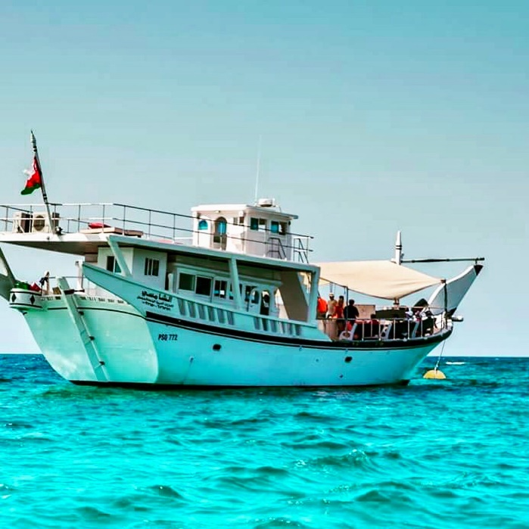 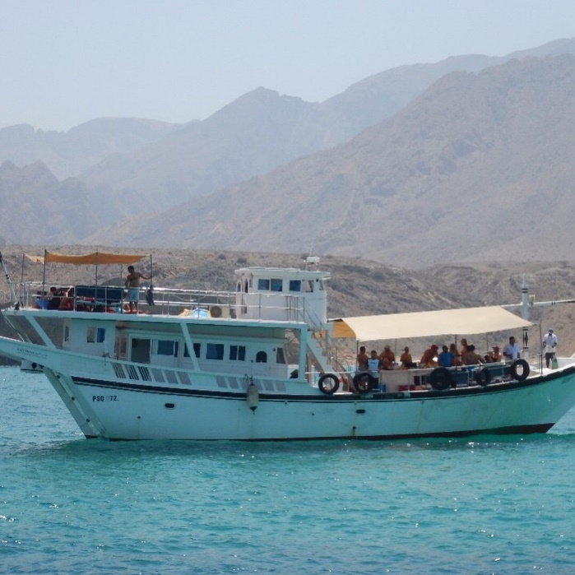

**Important:**

* The above itinerary can change depending on weather
* If the trip is cancelled due to bad weather/rough sea the payments will be refunded. If already in Oman we will organize an alternative trip (visit to nearby Al Sawadi islands and/or forts of Barka, Nakhal, Ar Rustaq).
* To secure the dhow and permits, 500 AED prepayment will be collected
* The space will be assigned on first paid basis. Only participants with fully prepaid Daymaniyat boat trip will be considered as signed up - no waiting list.
* Children count as adults.
* If less than 20 payments are collected by 10 October, the boat trip will be cancelled
* Prepayments are not refundable in case of cancellations, no shows or late arrival to the port.
* This is an exclusively snorkeling trip; we will only stop at the beaches & depths suitable for snorkeling (no diving).

If interested, please contact Sonja at [lavson@gmail.com](mailto:lavson@gmail.com)

More about Daymaniyat Islands below:

**Daymaniyat Islands**

|  |
| --- |
| Damaniyat Island |
| **2.Hycoon, 3.Al Qafsiyah, 4.Al Jabal Kabeer, 5.Al Qurfah, 6.Wlad Al Quarfah, 7.Qesmah** |

The nine, tiny, uninhabited islands lie about 11 miles off the Batinah Coast offer some of the best snorkeling in the Gulf of Oman. Coral reefs cover up to 70% of the sites with more than a hundred different species of soft and hard coral. Marine life is abundant with prolific numbers of colorful reef fish, stingrays, occasional turtles, leopard sharks and on rare occasions a whale shark. With the vast variety of sea life and coral close to the surface, snorkeling is a particularly rewarding experience.

The islands have been protected as a **nature reserve** since 1996 and provide an important nesting site for hawksbill and green turtles, as well as a wide range of migratory birds including the increasingly rare sooty falcon (which can also be found in the Sawadi Islands), one of the few migratory raptors which nests and breeds in the region.

Given their protected status, access to the Daymaniyats is restricted, and visitors are not allowed on the islands from the beginning of May until the end of October. In winter months the visits are allowed upon obtaining prior permit.

